MyIAM Micro-Plan
Oct 8, 2026 · @Hameed

Plan Overview
MyIAM micro-plan covers 5 delivery workstreams running in parallel from Oct 2026 through Feb 2027, with UX refinement as a continuous sixth track. All modules must reach dev-complete before the canary sequence begins in March 2027.
Workstream | Start | Target Complete
Data Collect (AD → MyIAM DB) | Oct 8 | End of October
Password Reset | Oct 8 | Beginning of November
Core API / AD Write Consolidation | Oct 8 | End of Nov / Dec first week
Solution & Context | Nov 1 | Mid-December
Groups | Mid-Nov | Mid-January
Accounts | Dec 1 | End of February
UX Refinement (all modules) | Oct 8 | Ongoing — parallel to all above

Sprint Plan
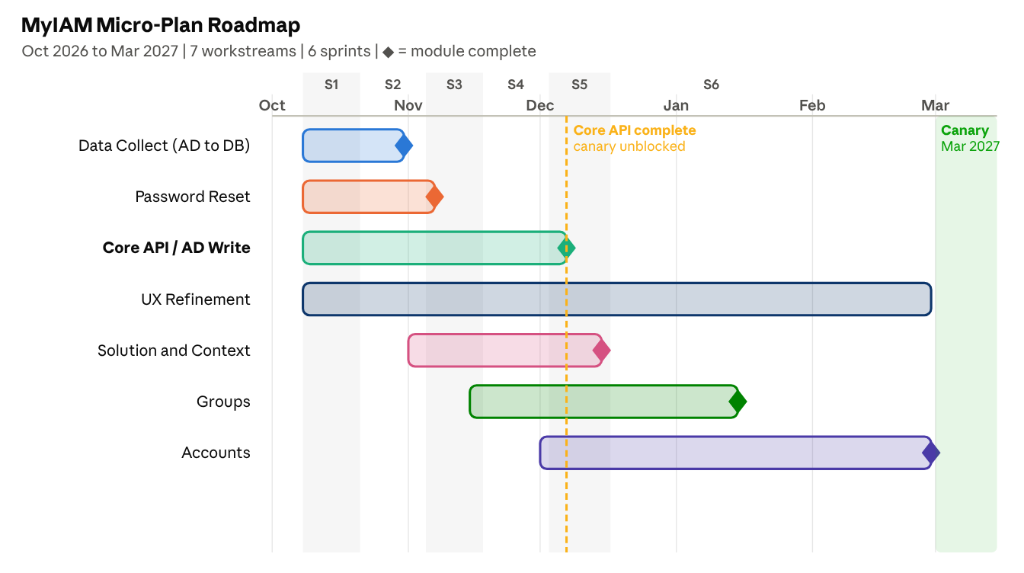
MyIAM workstreams · 7 parallel tracks · Oct 2026 to Feb 2027

Sprint 1 — Oct 8 to Oct 21
Theme: Foundation sprint — all workstreams in motion
Workstream | Scope this sprint | Owner
Data Collect | Integrate remaining AD sources into Prefect pipeline; validate completeness | Data engineer
Password Reset | Add AD write call, policy validation, notification triggers | Team A Dev 1 + Team B backend
Core API / AD Write | Finalize architecture design; get sign-off from architect | Architect + Team B backend
Accounts API | Schema design + base API scaffolding | Team A Dev 2
Solution & Context | Gap analysis against current API; begin hardening | Team A Dev 3
UX Refinement | Begin refinement pass on Password Reset and Solution screens | UX
Sprint exit criteria
- Password Reset business logic code-complete
- Accounts schema scaffolded
- Core API design signed off
- Data Collect on track for Oct 31 closure

Sprint 2 — Oct 22 to Nov 4
Theme: Password Reset to done; Core API build begins
Workstream | Scope this sprint | Owner
Data Collect | Final source integrations; close and validate full AD read | Data engineer
Password Reset | Integration testing, defect fixes, sign-off | Team A Dev 1 + QA
Core API / AD Write | Sprint 1 of implementation — AD connection layer + shadow write setup | Team B backend + Architect
Accounts API | Business logic layer complete | Team A Dev 2
Solution & Context | Integration testing; canary prep begins | Team A Dev 3 + Team B
UX Refinement | Groups and Accounts UX refinement pass | UX
Sprint exit criteria
- ✅ Password Reset module dev-complete (first module done)
- ✅ Data Collect closed — all AD data in MyIAM DB
- Core API AD connection layer functional
- Accounts business logic complete

Sprint 3 — Nov 5 to Nov 18
Theme: Core API mid-build; Solution & Context closes
Workstream | Scope this sprint | Owner
Core API / AD Write | Sprint 2 — dual-write shadow mode; internal write validation | Team B backend + Architect
Solution & Context | Final testing + sign-off | Team A Dev 3 + QA
Groups | API + schema build begins (most complex asset) | Team B backend
Accounts API | Integration testing; UX alignment | Team A Dev 2
UX Refinement | Groups UX refinement pass | UX
Sprint exit criteria
- ✅ Solution & Context module dev-complete
- Core API dual-write shadow validated internally
- Groups API underway
- Accounts integration testing in progress

Sprint 4 — Nov 19 to Dec 2
Theme: Core API completion; Groups and Accounts in build
Workstream | Scope this sprint | Owner
Core API / AD Write | Final implementation — all asset write paths connected and tested | Team B backend + Architect
Groups | Business logic + write path integration | Team B backend
Accounts API | Final testing + sign-off prep | Team A Dev 2 + QA
UX Refinement | Accounts UX refinement pass | UX
Sprint exit criteria
- ✅ Core API / AD Write Consolidation complete (all modules unblocked)
- Groups build 60% complete
- Accounts nearing sign-off

Sprint 5 — Dec 3 to Dec 17
Theme: Groups closes; all prior modules production-ready
Workstream | Scope this sprint | Owner
Groups | Final testing + sign-off | Team B + QA
Accounts | Continued build + testing | Team A Dev 2
All modules | Production readiness checklist per module; OpenShift hosting validation | DevOps + PO
UX Refinement | Final UX pass across all complete modules | UX
Sprint exit criteria
- ✅ Groups module dev-complete
- All prior modules (Password Reset, Solution & Context, Core API) production-ready
- Accounts 50% complete

Sprint 6 — Dec 18 to Jan 15
Theme: Accounts closes; platform stabilization
Workstream | Scope this sprint | Owner
Accounts | Final build, testing, and sign-off | Team A Dev 2 + QA
All modules | Platform-wide regression; performance validation | Team B + QA
UX Refinement | Close all outstanding UX items | UX
Sprint exit criteria
- ✅ Accounts module dev-complete
- Full platform regression passed
- All 5 modules ready for canary sequence starting March 2027

Milestone Summary
# | Milestone | Target Date | Module
M1 | Data Collect complete — full AD read in MyIAM DB | End of October 2026 | Infrastructure
M2 | Password Reset — dev and testing complete | Beginning of November 2026 | Password Reset
M3 | Core API / AD Write Consolidation complete | End of November / Dec first week 2026 | All modules
M4 | Solution & Context — dev and testing complete | Mid-December 2026 | Solution & Context
M5 | Groups — dev and testing complete | Mid-January 2027 | Groups
M6 | Accounts — dev and testing complete | End of February 2027 | Accounts
M7 | Canary sequence begins | March 2027 | All modules
Key dependency: M3 (Core API) is a prerequisite for all module canaries. All modules complete their own dev and testing independently, but none can go to canary until M3 is done.

